Evaluate ways to increase customers

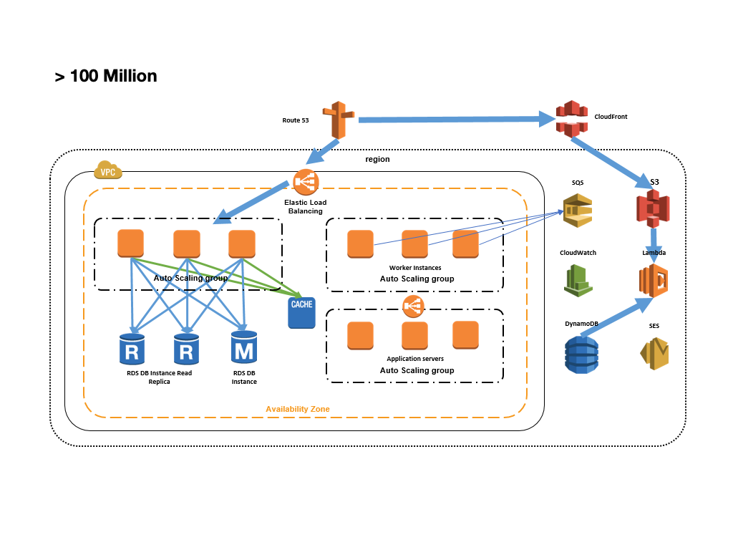

Deploying across multiple Availability Zones

Using Elastic Load Balancing (ELB) between tiers

Using Auto Scaling

Using service-oriented architecture

Serving content using appropriate AWS services (for example, local vs. Elastic Block Store vs. S3)

Caching off DB using ElastiCache

Moving state off tiers so you can horizontally scale

Database Federation

Data Warehouse

MDM Strategy

Big Data Characteristics